# Institute of Information Technology (IIT)

Jahangirnagar University



# ICT 4202– Digital Image Processing Lab

# LAB REPORT

**SUBMITTED BY**

Name: Md. Shakil Hossain

Roll No:2023

Exam Roll:192340

# SUBMITTED TO

Mehrin Anannya

Assistant Professor, IIT

**Contents**

Lab Report - 01 3

Task 1(a): 3

Code: 3

Output: 3

Task 1(b): 3

Code: 3

Output: 4

Task 2(a): 4

Code: 4

Output: 5

Task 2(b): 5

Code: 5

Output: 6

Lab Report - 02 7

Task 1: 7

Code: 7

Output: 8

Lab Report - 04 9

Task 1: 9

Code: 9

Output: 9

Lab Report - 05 9

Task 1: 10

Code: 10

Output: 11

Lab Report - 06 12

Task 1: 12

Code: 12

Output: 13

Lab Report - 07 14

Task 1: 14

Code: 14

Output: 15

Task 2: 16

Code: 16

Output: 16

Task 3: 18

Code: 18

Output: 20

Code for another image: 22

Output: 24

# Lab Report - 01

## **Task 1(a):**

### **Code:**

print("Answer of 1a(i): "+ str(x[2]))

print("Answer of 1a(ii): "+ str(x[1][2]))

print("Answer of 1a(iii): "+ str(x[1][1:3]))

output = [num for num in x[0] if num % 2 != 0]

print("Answer of 1a(iv): "+ str(output))

### **Output:**

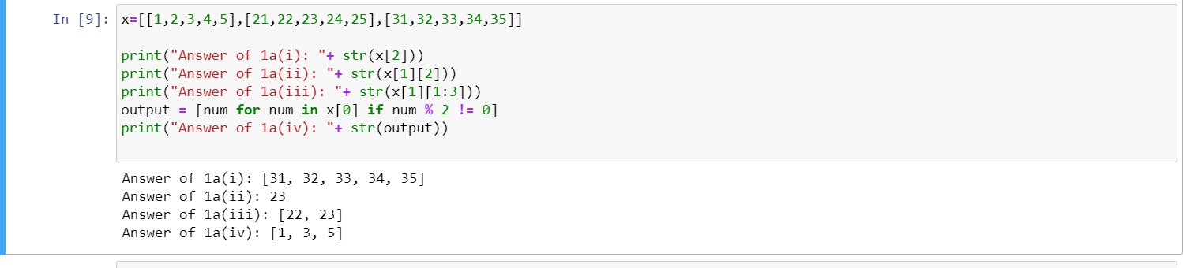

## **Task 1(b):**

Declare y = [0, 0, 0], now using for loop write average of first list in list ‘x’ on first index of list y and so on. The print(y) should give the output: [3.0, 23.0, 33.0]

### **Code:**

y = [0, 0, 0]

for i in range(3):

for j in range(5):

y[i] += x[i][j]

print(y)

for i in range(3):

y[i] /= 5

print(y)

### **Output:**

## **Task 2(a):**

x = [1, 3, 5, 6, 7, 8, 6, 1, 2, 3] y = [0, 0, 0, 0, 0, 0, 0, 0]

1. Write python code using a while loop that writes the average of the first three items on the first index of y and so on. The print(y) should give the following output

Output : [3.0, 4.666666666666667, 6.0, 7.0, 7.0, 5.0, 3.0, 2.0]

### **Code:**

X = [1,3,5,6,7,8,6,1,2,3]

Y = [0,0,0,0,0,0,0,0]

for i in range(8):

for j in range(3):

y[i] += x[i+j]

print(y)

for i in range(8):

y[i] /= 3

print(y)

### **Output:**

## **Task 2(b):**

Define a function that takes list length as argument and returns the average. Then calculate the average of x and y.

### **Code:**

def avg1(ar,len): t=0

for i in range(len):

t+=ar[i]

t/=len return t

xavg=avg1(x,len(x))

print(xavg)

yavg=avg1(y,len(y))

print(yavg)

### **Output:**

# Lab Report - 02

## **Task 1:**

Save our university logo from the website and read it in gray scale and as a colour image. Show it in GUI. Then save it in a different directory.

### **Code:**

import cv2

import os

import numpy as np

from matplotlib import pyplot as plt

c_img=cv2.imread('JU_logo.png',cv2.IMREAD_COLOR)

g_img=cv2.imread('JU_logo.png',0)

pr=r' F:\Github\Digital-Image-Processing-Lab'

os.chdir(pr)

print("before image")

print(os.listdir(pr))

cv2.imshow('gray image',g_img)

cv2.imshow('color image',c_img)

cv2.waitKey(0)

cv2.destroyAllWindows()

cv2.imwrite('g_img.png',g_img)

cv2.imwrite('c_img.png',c_img)

print("after image")

print(os.listdir(pr))

### **Output:**



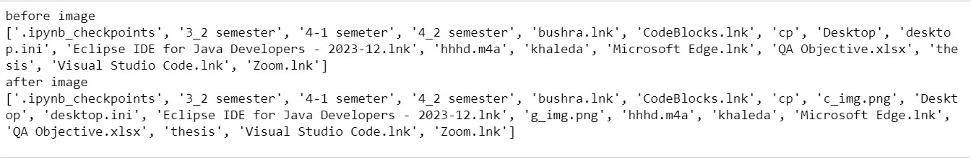

# Lab Report - 04

## **Task 1:**

Using the for loop and glob library read all the image files and rename all of them according to loop.

### **Code:**

import os

import glob

co=0

path='*.*'

os.chdir(r'F:\Github\Digital-Image-Processing-Lab\Lab 4\Code\Images')

print("before rename")

print(os.listdir())

for i in glob.glob(path):

va='new'+str(co)+'.jpg'

co+=1

os.rename(i,va)

print("after rename")

print(os.listdir())

### **Output:**

# 

# Lab Report - 05

## **Task 1:**

Take a screenshot of an image and apply gaussian filtering on the background of the image and find edged from it.

### **Code:**

import cv2

import matplotlib.pyplot as plt

import numpy as np

from skimage import io

from skimage.filters import gaussian, sobel

img=(cv2.imread("ss.png",0))

fig=plt.figure(figsize=(20,20))

g1=gaussian(img, sigma=1, mode='constant', cval=0.0)

g2=cv2.GaussianBlur(img, (3,3), 0, borderType=cv2.BORDER_CONSTANT)

i1=fig.add_subplot(2,2,1)

i1.set_title("gaussian filtered image")

i1.imshow(g1)

i2=fig.add_subplot(2,2,2)

i2.set_title("gaussian blur filtered image")

i2.imshow(g2)

#sobel

so=sobel(g2)

fig=plt.figure(figsize=(20,20))

f1=fig.add_subplot(2,2,3)

f1.set_title("sobel edge detection")

f1.imshow(so)

#canny

ca=cv2.Canny(g2,100,200)

f2=fig.add_subplot(2,2,4)

f2.set_title("canny edge detection")

f2.imshow(ca)

### **Output:**

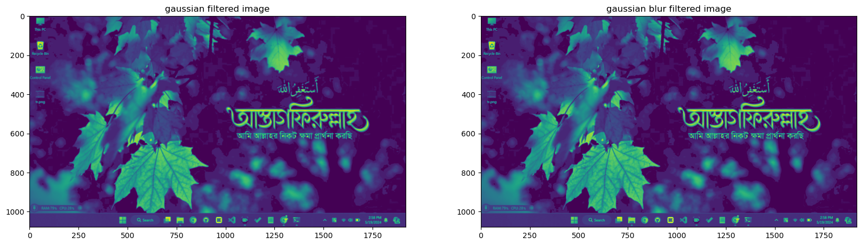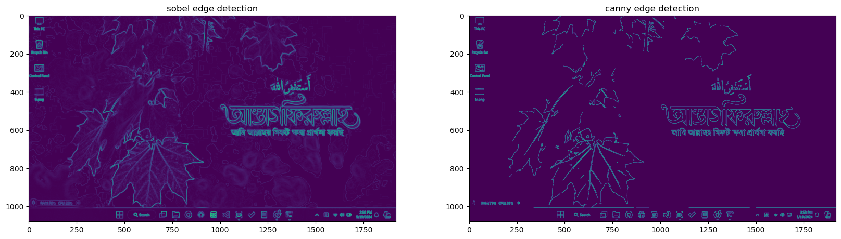

# Lab Report - 06

## **Task 1:**

Take two images and compare between any two filtering techniques and write necessary comments on it mentioning which filtering techniques works well on the images.

### **Code:**

import cv2

import bm3d

import matplotlib.pyplot as plt

from skimage.filters import median

from skimage.restoration import denoise_tv_chambolle

img=(cv2.imread("noise.jpg",0))

fig=plt.figure(figsize=(20,20))

v1=denoise_tv_chambolle(img, weight=0.1, eps=0.0002,n_iter_max=200, channel_axis=False)

b1=bm3d.bm3d(img, sigma_psd=0.2,stage_arg=bm3d.BM3DStages.HARD_THRESHOLDING)

i1=fig.add_subplot(2,3,1)

i1.set_title('original image')

i1.imshow(img)

i2=fig.add_subplot(2,3,2)

i2.set_title('after appling denoise tv chambolle')

i2.imshow(v1)

i3=fig.add_subplot(2,3,3)

i3.set_title('after appling bm3d')

i3.imshow(b1)

img1=(cv2.imread("ss.png",0))

fig=plt.figure(figsize=(20,20))

v1=denoise_tv_chambolle(img1, weight=0.1, eps=0.0002,n_iter_max=200, channel_axis=False)

b1=bm3d.bm3d(img1,sigma_psd=0.2,stage_arg=bm3d.BM3DStages.HARD_THRESHOLDING)

i1=fig.add_subplot(2,3,4)

i1.set_title('original image')

i1.imshow(img1)

i2=fig.add_subplot(2,3,5)

i2.set_title('after appling denoise tv chambolle')

i2.imshow(v1)

i3=fig.add_subplot(2,3,6)

i3.set_title('after appling bm3d')

i3.imshow(b1)

### **Output:**

# 

# 

# Lab Report - 07

## **Task 1:**

Take two images and compare between any two edge detection techniques and write necessary

### **Code:**

import cv2

import numpy as np

import matplotlib.pyplot as plt

from skimage import io

from skimage.filters import gaussian, sobel

img=(cv2.imread("new4.jpg",0))

fig=plt.figure(figsize=(20,8))

so=sobel(img)

ca=cv2.Canny(img,100,200)

i1=fig.add_subplot(2,3,1)

i1.set_title('original image')

i1.imshow(img)

i2=fig.add_subplot(2,3,2)

i2.set_title('edge detection using sobel')

i2.imshow(so)

i3=fig.add_subplot(2,3,3)

i3.set_title('edge detection using canny')

i3.imshow(ca)

img1=(cv2.imread("apple.jpg",0))

fig=plt.figure(figsize=(20,8))

so=sobel(img1)

ca=cv2.Canny(img1,100,200)

i1=fig.add_subplot(2,3,4)

i1.set_title('original image')

i1.imshow(img1)

i2=fig.add_subplot(2,3,5)

i2.set_title('edge detection using sobel')

i2.imshow(so)

i3=fig.add_subplot(2,3,6)

i3.set_title('edge detection using canny')

i3.imshow(ca)

### **Output:**

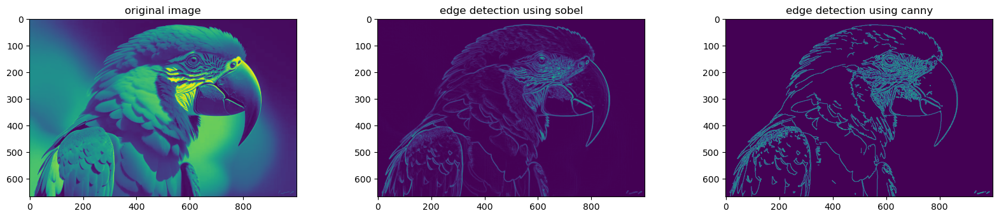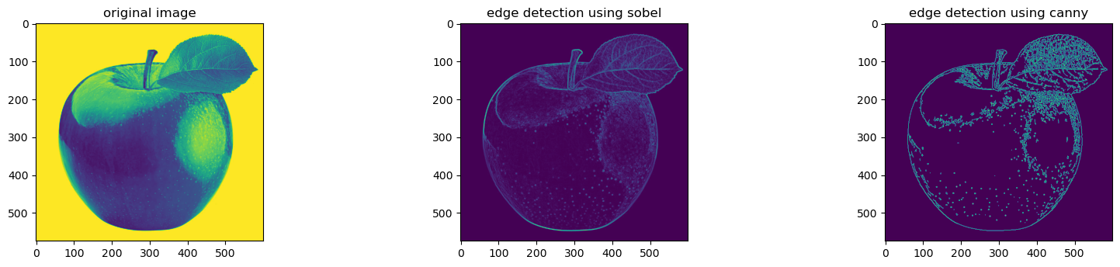

## **Task 2:**

Apply Fourier transform on those images.

### **Code:**

import cv2

import numpy as np

import matplotlib.pyplot as plt

from skimage import io

from skimage.filters import gaussian, sobel

img = cv2.imread('new4.jpg', 0)

dft = cv2.dft(np.float32(img), flags=cv2.DFT_COMPLEX_OUTPUT)

dft_shift = np.fft.fftshift(dft)

magnitude_spectrum = 20 * np.log((cv2.magnitude(dft_shift[:, :, 0], dft_shift[:, :,1]))+1)

fig = plt.figure(figsize=(8,6))

ax1 = fig.add_subplot(2,2,1)

ax1.imshow(img)

ax1.title.set_text('Input Image')

ax2 = fig.add_subplot(2,2,2)

ax2.imshow(magnitude_spectrum)

ax2.title.set_text('FFT of image')

plt.show()

img = cv2.imread('apple.jpg', 0)

dft = cv2.dft(np.float32(img), flags=cv2.DFT_COMPLEX_OUTPUT)

dft_shift = np.fft.fftshift(dft)

magnitude_spectrum = 20 * np.log((cv2.magnitude(dft_shift[:, :, 0], dft_shift[:, :,1]))+1)

fig = plt.figure(figsize=(8,6))

ax1 = fig.add_subplot(2,2,3)

ax1.imshow(img)

ax1.title.set_text('Input Image')

ax2 = fig.add_subplot(2,2,4)

ax2.imshow(magnitude_spectrum)

ax2.title.set_text('FFT of image')

plt.show()

### **Output:**

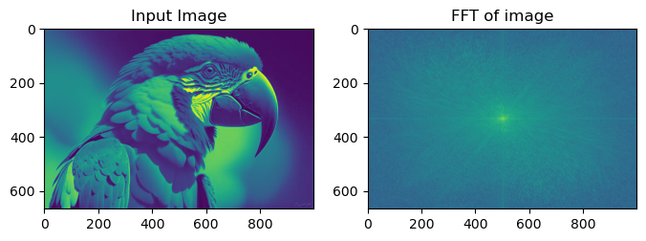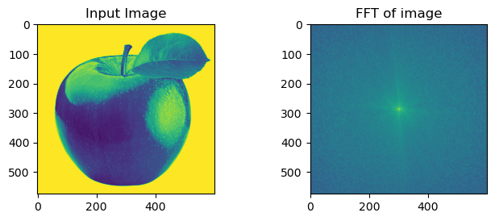

## **Task 3:**

Apply three pass filters on them and write you comment mentioning which filtering process is more feasible to extract the actual image.

### **Code:**

import cv2

import numpy as np

import matplotlib.pyplot as plt

from skimage import io

from skimage.filters import gaussian, sobel

img = cv2.imread('new4.jpg', 0)

dft = cv2.dft(np.float32(img), flags=cv2.DFT_COMPLEX_OUTPUT)

dft_shift = np.fft.fftshift(dft)

magnitude_spectrum = 20 * np.log(cv2.magnitude(dft_shift[:, :, 0], dft_shift[:, :, 1]))

fig = plt.figure(figsize=(10,10))

ax1 = fig.add_subplot(4,2,1)

ax1.imshow(img, cmap='gray')

ax1.title.set_text('Input Image')

ax2 = fig.add_subplot(4,2,2)

ax2.imshow(magnitude_spectrum, cmap='gray')

ax2.title.set_text('FFT of image')

# Circular HPF mask, center circle is 0, remaining all ones

rows, cols = img.shape

crow, ccol = int(rows / 2), int(cols / 2)

mask = np.ones((rows, cols, 2), np.uint8)

r = 80

center = [crow, ccol]

x, y = np.ogrid[:rows, :cols]

mask_area = (x - center[0]) ** 2 + (y - center[1]) ** 2 <= r*r

mask[mask_area] = 0

fshift = dft_shift * mask

epsilon = 1e-8

fshift_mask_mag = 20 * np.log(cv2.magnitude(fshift[:, :, 0], fshift[:, :, 1]) + epsilon)

f_ishift = np.fft.ifftshift(fshift)

img_back = cv2.idft(f_ishift)

img_back = cv2.magnitude(img_back[:, :, 0], img_back[:, :, 1])

fig = plt.figure(figsize=(10,10))

ax3 = fig.add_subplot(4,2,3)

ax3.imshow(fshift_mask_mag, cmap='gray')

ax3.title.set_text('FFT + high pass filter Mask')

ax4 = fig.add_subplot(4,2,4)

ax4.imshow(img_back, cmap='gray')

ax4.title.set_text('After inverse FFT usign high pass filter')

plt.show()

img = cv2.imread('new4.jpg', 0)

dft = cv2.dft(np.float32(img), flags=cv2.DFT_COMPLEX_OUTPUT)

dft_shift = np.fft.fftshift(dft)

magnitude_spectrum = 20 * np.log(cv2.magnitude(dft_shift[:, :, 0], dft_shift[:, :, 1]))

# Circular LPF mask, center circle is 1, remaining all zeros

rows, cols = img.shape

crow, ccol = int(rows / 2), int(cols / 2)

mask = np.zeros((rows, cols, 2), np.uint8)

r = 100

center = [crow, ccol]

x, y = np.ogrid[:rows, :cols]

mask_area = (x - center[0]) ** 2 + (y - center[1]) ** 2 <= r*r

mask[mask_area] = 1

fshift = dft_shift * mask

epsilon = 1e-8

fshift_mask_mag = 20 * np.log(cv2.magnitude(fshift[:, :, 0], fshift[:, :, 1]) + epsilon)

f_ishift = np.fft.ifftshift(fshift)

img_back = cv2.idft(f_ishift)

img_back = cv2.magnitude(img_back[:, :, 0], img_back[:, :, 1])

fig = plt.figure(figsize=(10,10))

ax3 = fig.add_subplot(4,2,5)

ax3.imshow(fshift_mask_mag, cmap='gray')

ax3.title.set_text('FFT + low pass filter Mask')

ax4 = fig.add_subplot(4,2,6)

ax4.imshow(img_back, cmap='gray')

ax4.title.set_text('After inverse FFT using low pass filter')

plt.show()

img = cv2.imread('new4.jpg', 0)

dft = cv2.dft(np.float32(img), flags=cv2.DFT_COMPLEX_OUTPUT)

dft_shift = np.fft.fftshift(dft)

magnitude_spectrum = 20 * np.log(cv2.magnitude(dft_shift[:, :, 0], dft_shift[:, :, 1]))

# Band Pass Filter - Concentric circle mask, only the points living in concentric circle are ones

rows, cols = img.shape

crow, ccol = int(rows / 2), int(cols / 2)

mask = np.zeros((rows, cols, 2), np.uint8)

r_out = 80

r_in = 10

center = [crow, ccol]

x, y = np.ogrid[:rows, :cols]

mask_area = np.logical_and(((x - center[0]) ** 2 + (y - center[1]) ** 2 >= r_in ** 2),

((x - center[0]) ** 2 + (y - center[1]) ** 2 <= r_out ** 2))

mask[mask_area] = 1

fshift = dft_shift * mask

epsilon = 1e-8

fshift_mask_mag = 20 * np.log(cv2.magnitude(fshift[:, :, 0], fshift[:, :, 1]) + epsilon)

f_ishift = np.fft.ifftshift(fshift)

img_back = cv2.idft(f_ishift)

img_back = cv2.magnitude(img_back[:, :, 0], img_back[:, :, 1])

fig = plt.figure(figsize=(10,10))

ax3 = fig.add_subplot(4,2,7)

ax3.imshow(fshift_mask_mag, cmap='gray')

ax3.title.set_text('FFT +band pass filter Mask')

ax4 = fig.add_subplot(4,2,8)

ax4.imshow(img_back, cmap='gray')

ax4.title.set_text('After inverse FFT using band pass filter')

plt.show()

### **Output:**

# 

### **Code for another image:**

import cv2

import numpy as np

import matplotlib.pyplot as plt

from skimage import io

from skimage.filters import gaussian, sobel

img = cv2.imread('apple.jpg', 0)

dft = cv2.dft(np.float32(img), flags=cv2.DFT_COMPLEX_OUTPUT)

dft_shift = np.fft.fftshift(dft)

magnitude_spectrum = 20 * np.log(cv2.magnitude(dft_shift[:, :, 0], dft_shift[:, :, 1]))

fig = plt.figure(figsize=(10,10))

ax1 = fig.add_subplot(4,2,1)

ax1.imshow(img, cmap='gray')

ax1.title.set_text('Input Image')

ax2 = fig.add_subplot(4,2,2)

ax2.imshow(magnitude_spectrum, cmap='gray')

ax2.title.set_text('FFT of image')

# Circular HPF mask, center circle is 0, remaining all ones

rows, cols = img.shape

crow, ccol = int(rows / 2), int(cols / 2)

mask = np.ones((rows, cols, 2), np.uint8)

r = 80

center = [crow, ccol]

x, y = np.ogrid[:rows, :cols]

mask_area = (x - center[0]) ** 2 + (y - center[1]) ** 2 <= r*r

mask[mask_area] = 0

fshift = dft_shift * mask

epsilon = 1e-8

fshift_mask_mag = 20 * np.log(cv2.magnitude(fshift[:, :, 0], fshift[:, :, 1]) + epsilon)

f_ishift = np.fft.ifftshift(fshift)

img_back = cv2.idft(f_ishift)

img_back = cv2.magnitude(img_back[:, :, 0], img_back[:, :, 1])

fig = plt.figure(figsize=(10,10))

ax3 = fig.add_subplot(4,2,3)

ax3.imshow(fshift_mask_mag, cmap='gray')

ax3.title.set_text('FFT + high pass filter Mask')

ax4 = fig.add_subplot(4,2,4)

ax4.imshow(img_back, cmap='gray')

ax4.title.set_text('After inverse FFT usign high pass filter')

plt.show()

# Circular LPF mask, center circle is 1, remaining all zeros

rows, cols = img.shape

crow, ccol = int(rows / 2), int(cols / 2)

mask = np.zeros((rows, cols, 2), np.uint8)

r = 100

center = [crow, ccol]

x, y = np.ogrid[:rows, :cols]

mask_area = (x - center[0]) ** 2 + (y - center[1]) ** 2 <= r*r

mask[mask_area] = 1

fshift = dft_shift * mask

epsilon = 1e-8

fshift_mask_mag = 20 * np.log(cv2.magnitude(fshift[:, :, 0], fshift[:, :, 1]) + epsilon)

f_ishift = np.fft.ifftshift(fshift)

img_back = cv2.idft(f_ishift)

img_back = cv2.magnitude(img_back[:, :, 0], img_back[:, :, 1])

fig = plt.figure(figsize=(10,10))

ax3 = fig.add_subplot(4,2,5)

ax3.imshow(fshift_mask_mag, cmap='gray')

ax3.title.set_text('FFT + low pass filter Mask')

ax4 = fig.add_subplot(4,2,6)

ax4.imshow(img_back, cmap='gray')

ax4.title.set_text('After inverse FFT using low pass filter')

plt.show()

# Band Pass Filter - Concentric circle mask, only the points living in concentric circle are ones

rows, cols = img.shape

crow, ccol = int(rows / 2), int(cols / 2)

mask = np.zeros((rows, cols, 2), np.uint8)

r_out = 80

r_in = 10

center = [crow, ccol]

x, y = np.ogrid[:rows, :cols]

mask_area = np.logical_and(((x - center[0]) ** 2 + (y - center[1]) ** 2 >= r_in ** 2),

((x - center[0]) ** 2 + (y - center[1]) ** 2 <= r_out ** 2))

mask[mask_area] = 1

fshift = dft_shift * mask

epsilon = 1e-8

fshift_mask_mag = 20 * np.log(cv2.magnitude(fshift[:, :, 0], fshift[:, :, 1]) + epsilon)

f_ishift = np.fft.ifftshift(fshift)

img_back = cv2.idft(f_ishift)

img_back = cv2.magnitude(img_back[:, :, 0], img_back[:, :, 1])

fig = plt.figure(figsize=(10,10))

ax3 = fig.add_subplot(4,2,7)

ax3.imshow(fshift_mask_mag, cmap='gray')

ax3.title.set_text('FFT +band pass filter Mask')

ax4 = fig.add_subplot(4,2,8)

ax4.imshow(img_back, cmap='gray')

ax4.title.set_text('After inverse FFT using band pass filter')

plt.show()

### **Output:**

# 

**The End**